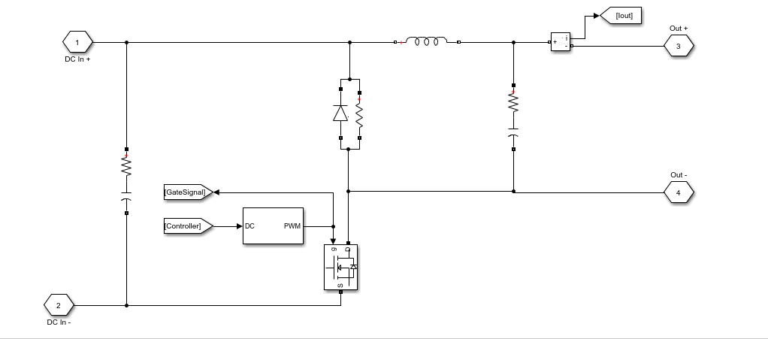

*Figure x. Modified Buck Converter Topology*

Modified buck topology was discovered while researching about controllers for the project. A modified buck converter generally intends for high brightness LED applications. Also, these converters are designed as a constant current source to achieve the best lighting performance from the LEDs. In our project, constant output current is the main aim, therefore modified buck topology was chosen. Furthermore, modified buck topology is chosen for controllers of constant current applications because the power switch is connected to ground rather than the high side switch, like in a standard buck topology, thus control is easier. While the switch is on state, increasing current will flow through battery and when the switch is off state, the inductor keeps the current flowing in the same direction and the diode will be open and inductor current decreasing. This cycle continues like this. Details about relation between controller and modified buck converter will be explained in the controller part.

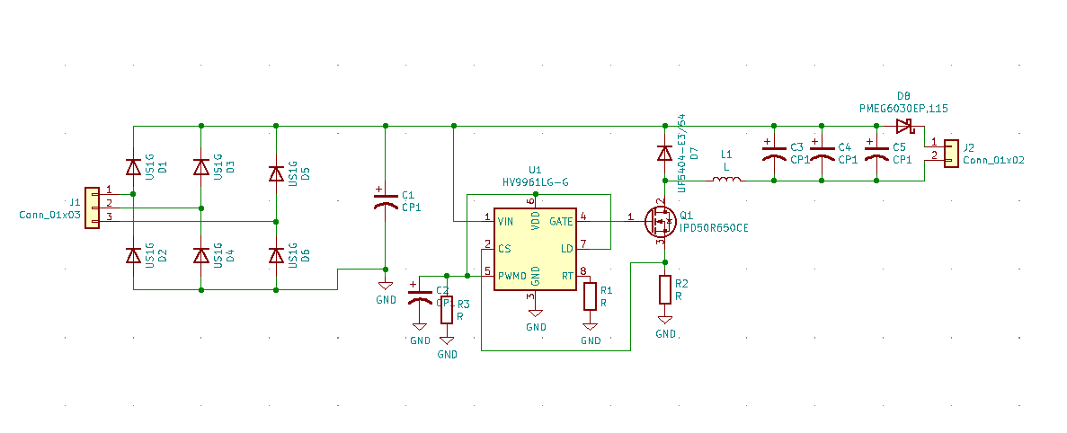

Figure. Final Topology of the Project

3-phase AC input voltage is converted to DC by using a 3-phase diode rectifier and DC link capacitor, then operate controller in constant current mode and obtain a constant output current with the buck converter. Before the battery, additional diode is used in topology. Thanks to the diode, when input voltage is lower than battery voltage, the battery will not lose energy and the topology will not be adversely loaded. Details of the topology will be explained later.